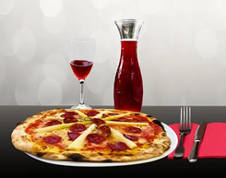

**Pizza Store Location Opportunity**

**Preliminary Analysis**

**(Kansas City, Missouri)**

**July 5, 2020**

# **Introduction**

## **Background**

Americans eat on average 23 pounds of pizza per year equating to about 46 slices of pizza per person. Each day, on average, 13% of Americans eat pizza. Over 93% of Americans eat pizza. Pizza sales are increasing 2.3% per year on average since 2014. Fast casual restaurants are the fastest growing segment of the restaurant market, and the “step-up from fast food” is finding great success in the pizza market. Fast casual pizza is focused on winning the lunch crowd, while traditional pizza stores focus on dinner and delivery. A group of investors would like to know if there is an opportunity to open a pizza shop within 3 miles of the downtown Kansas City area given that downtown Kansas City, Missouri has 81,740 jobs, and the average American spends 85% of their income within 5 miles of their home. Within 3 miles of downtown Kansas City, Missouri, the population is 88,759.

## **Problem**

Because it cost between $295,000-$422,000 to open a pizza shop, the investors would like to explore preliminary data to determine whether a more thorough analysis is justified. At this time, there is not enough information to justify opening a pizza shop. The assumption is that the more people that can support a store, the higher the opportunity for higher revenues and higher profitability.

# **Data Methodology**

## **Data Sources**

Foursquare data is being used to identify pizza shops within 3 miles of downtown Kansas City, Missouri. The Foursquare data will also provide the Postal Codes for each location. Population by Postal Codes is provided by Zip.org. This data will be used to identify population size by Postal Code. Population size will be used to determine how many people there are per store by Postal Code. Median income by Postal Code, provided by incomebyzipcode.com/Missouri will be used to support the final recommendation.

## **Data Cleaning**

Accessed Foursquare Pizza Shop Venues near the center of downtown Kansas City MO.

LIMIT = 30 # limit of number of venues returned by Foursquare API

radius = 5400 # define radius in meters (approximately 3 miles).

Cleaned population by Postal Code by deleting Postal Codes that were not included within 5400 meters of Kansas City, MO - latitude = 39.0997 longitude = -94.5786.

# **Exploratory Data Analysis**

## **Relationship Between Store Location and Population**

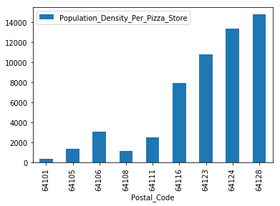

It appears based on Postal Codes 64123, 64124, and 64128 that the areas are underserved.

## **Relationship Between Store Location and Median Income**

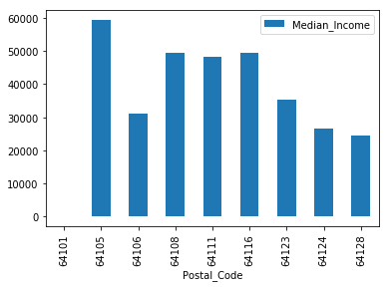

The data suggest that median income could be an indicator of where to locate a pizza store. The assumption is that a higher median income provides a higher disposable income.

# **Relationship Between Number of Stores and Median Income**

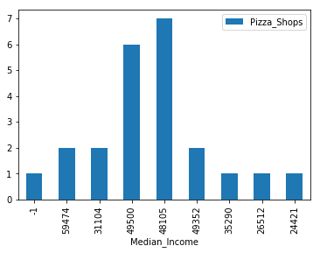

It appears that median income is correlated to the number of stores. The higher the median income, the higher number of stores.

# **Clustering**

Clustered by Postal Code to analyze the relationship between median income, population, and pizza store count by Postal Code.

# 

### **Cluster 0 – Yellow**

Second highest population. Lowest median income.

### **Cluster 1 – Purple**

Second lowest population. Highest median income.

### **Cluster 2 – Bluegreen**

Highest population. Second highest median income.

### **Cluster 3 – Yellow**

Lowest population. Lowest median income.

# **Conclusions**

The data suggest that high median income and high population density is required to support multiple pizza stores. The Postal Codes with low median income and low population density have one pizza store. Postal Codes with the highest median income and the highest population have multiple stores.

Cluster 2 appears to provide an opportunity that needs to be further reviewed.

# **Recommendation**

A more thorough analysis is required to better understand the relationship between family structure, age, and convenience. The lack of time could also be a factor along with population and median income in determining a proper location for a pizza store.

|  |  |
| --- | --- |
|  |  |